NAME____________________________LAB MEETING DAY/TIME______________

Lab 7: Geologic Maps - KEY

In this lab you will examine geologic maps, and the ways they help us understand the features of a landscape. You will be completing Exercise 13 in your lab manual for this lab.

# **Exercise 13, Part A**

**Question 1:**

***Students should draw the line on the map as shown below, connecting the points they draw from the cross-section. They can add more points, but fewer might not show the whole outcrop of the coal. The directions also ask them to color the units on the map (its okay if they do not)***

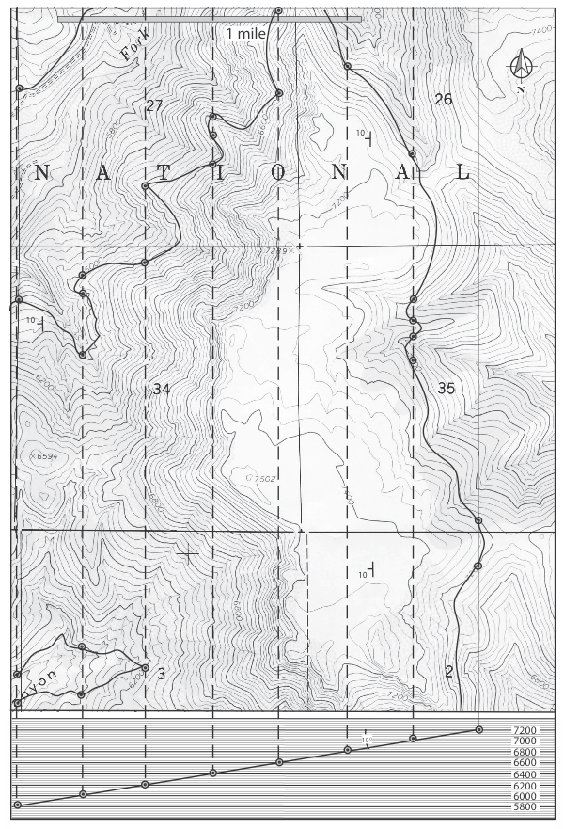

**Question 2:**

***The coal seam is exposed across the entire east face of the mountain. It also crops out on the northwest side of the mountain as well as in the canyon at the lower left of the map. The lowest elevation of coal exposure in the map is 5,800 ft.***

# **Exercise 13, Part B**

**Question 1: Follow the directions in this question to complete the geologic cross section below. The easiest way to do this will be to fold this page and lie it along line A-A’ on the map on page 204 of your lab manual.**

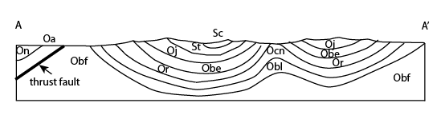

**Question 2:**

***anticlines and synclines.***

**Question 3:**

***Strata become younger towards the center of a syncline. Strata are older in the core of an anticline.***

**Question 4:**

***Compressional***

**Question 5:**

***Bald Eagle Formation, Juniata Formation, and Tuscarora Formation.***

# **Exercise 13, Part C**

**Question 1: Follow the directions in this question to complete the geologic cross section below. The easiest way to do this will be to fold this page and lie it along line A-A’ on the map on page 214 of your lab manual.**

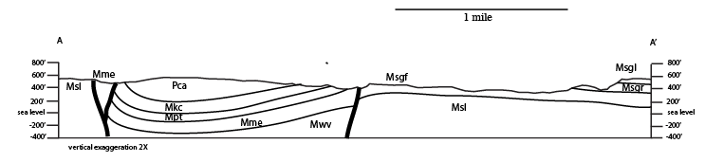

**Question 2: Note that “geologic systems” refer to the rock units on the map.**

***Mississippian and Pennsylvanian.***

**Question 3:**

***The syncline is asymmetrical, meaning that strata on the west limb dip more steeply than those on the east limb.***

**Question 4:**

***Normal faults. The footwall (block between two main faults) is down relative to the hanging wall blocks.***

# **Exercise 13, Part D**

**Question 1: Note that “geological systems” is referring to the rock units present.**

***Paleozoic Systems: Cambrian, Carboniferous, Permian***

***Mesozoic Systems: Triassic, Jurassic, Cretaceous.***

**Question 2:**

***The Ordovician, Silurian, and Devonian Systems are not represented in the area***

**Question 3: Note that “nature of the contact” is asking for the type of unconformity.**

***Nonconformity***

**Question 4:**

***Paraconformity or disconformity. From figure 1.1 on page 2, the Ordovician, Silurian, and Devonian (missing systems) equate to 129.1 million years of earth history***

**Question 5:**

***In the south end of the map area, the Skull Creek rests upon the Sundance Formation. In the northern part of the map area, the regionally discontinuous Morrison Formation is present. Hence the Morrison Formation was eroded from much of the area prior to deposition of the Skull Creek Formation.***

**Question 6:**

***Greenhorn (Kg), Mowry (Kbm), Skull Creek (Ks), Sundance (Js), Spearfish (Trs), Minnekata (Pm), and Minnelusa (Cm).***

**Question 7:**

***Angular unconformity.***

**Question 8:**

***The folding occurred after deposition of the Cretaceous Greenhorn Limestone and the Tertiary White River. Thus the folding occurred in latest Cretaceous to early Tertiary time.***

**Question 9:**

***Angular unconformities are indicated by cross-cutting of formation contacts. Disconformities are indicated by parallel formation contacts***

# **Lab 7 Reflection**

**What are the differences and similarities between geologic maps, topographic profiles, and geologic cross sections?**

***Answers should describe how these are used and what they show***

**How do you feel about interpreting geologic maps after this lab? What seems easiest? What needs more explanation?**

***Any answers are good here, as long as they demonstrate reflection***